Robin Hood Road Sewer Replacement

HRSD, your regional wastewater treatment utility, is planning a project in your neighborhood to replace the existing HRSD sanitary sewer pipelines that are nearing the end of their useful life. This replacement project will also improve the system’s performance and ensure continued, reliable sewer service in the future. The answers to some Frequently Asked Questions (FAQs) are provided on the back of this notice.

Project Overview
HRSD is undertaking a project to replace the sanitary sewer pipeline along Robin Hood Road between Chesapeake Boulevard and Birch Street. This effort will improve performance and reliability within HRSD’s sanitary sewer system. A guided auger bore will be used to install the new sewer pipe under a large storm drain near Glen Avenue and Robin Hood Road. The auger bore allows for installation without cutting open the road above it. The remainder of the new sewer pipe will be installed in a trench, meaning pavement cutting and excavation will be necessary to install the new pipe. Pavement restoration of the roadways affected by installation of the sewer pipe will occur once the sewer installation is complete. The existing sewer pipe will not be needed once the new sewer pipe is installed; it will be abandoned in place without disturbing the ground above.
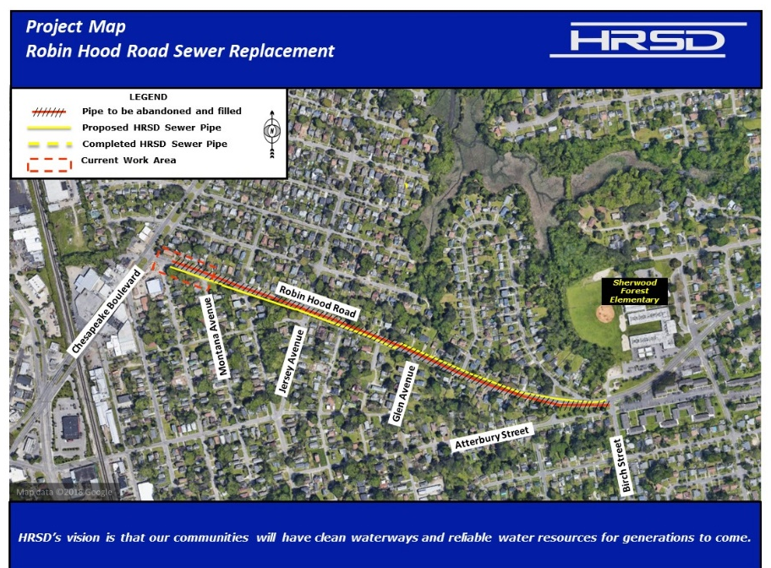
Project Schedule

Staging: September 2023

Construction:
Fall 2023 – Spring 2025

Restoration:
Immediately following construction when seasonably appropriate

QR
Code

You also may visit www.hrsd.com/construction-status for additional information and project updates

If you have any questions about the project, please contact PIS Name, HRSD Public Information Specialist, at 757.XXX-XXXX or XXXX@hrsd.com

Thank you for your support of this effort to help achieve HRSD’s vision: Our communities will have clean waterways and reliable water resources for generations to come.

Why is this project necessary?
A. This project is necessary to upgrade aging infrastructure that will help ensure HRSD’s ability to protect public health and the environment for decades to come.

Will the project affect the flow of traffic in the neighborhood?
A. Disruptions to traffic will be minimized. Detours and lane closures with flaggers will be used to help direct traffic as needed.

Will access to properties along the route be maintained during construction?
A. The contractor will ensure that access to residences will be maintained throughout construction. Trash and mail services should not be affected. If necessary, the contractor will move trash containers from within a work zone to an area accessible for pickup and will be responsible for returning them to each residence.

What are the general working hours for the project?
A. Work will typically take place Monday through Friday from 7 AM - 7 PM; there may be exceptions in certain locations to reduce impacts to the community, adhere to City ordinances, or as required in order to complete the work.

Will there be any interruptions to my water or sewer service?
A. Your water and sewer service may be briefly affected by this project. Every attempt will be made to provide an advance notice of this interruption if it is to occur so you can plan appropriately.

Will construction affect the existing pavement?
A. Where sewer pipeline is installed, asphalt, curb, gutters, driveway aprons, and grass will be removed and then restored upon completion of the project.

What sort of noise should I expect during construction?
A. The typical construction noises such as equipment engines, materials being delivered, diesel generators, air compressors, sawing, and associated activities should be anticipated.

Will material and equipment be stored on-site?
A. The contractor has negotiated with a private property owner for a storage area in the project vicinity and this site will be used for most of the equipment and supplies. The contractor will keep some supplies within the active work zone, in the public right-of-way.

Where will construction workers park?
A. Construction workers will not be allowed to park their personal vehicles on the public streets. However, work trucks will be allowed to park within the active work zone.

What is the cost of the project?
A. The estimated cost for the project is approximately $5 million and is financed by the wastewater treatment fees paid by HRSD customers.

How can I receive regular project updates?
A. Regular project updates are posted on the HRSD website at www.hrsd.com/construction-status. You may also sign up at www.hrsd.com/subscriptions to receive an email notification whenever the website has an update about the project.

