Notice of Informational Open House

Dear Neighbors:

In coordination with York County, HRSD, your regional wastewater treatment utility, invites you to attend an Open House to learn about the Tabb Pressure Reducing Station & Offline Storage Facility. HRSD is undertaking a project to construct the Tabb Pressure Reducing Pump Station and Offline Storage Facility, which will include the construction of two 2.5-million-gallon offline storage tanks and a pressure-reducing pump station. The new facility will be located on HRSD property located at 900 Yorktown Road in Yorktown and is designed to relieve pressures to the sewer system during wet weather events and provide flow balancing for HRSD’s James River and York River Treatment Plants. The facility will improve system operations, increase flow capacity, and offer reliable sanitary sewer infrastructure for your community and the region. Additionally, these system improvements are mandated by the EPA to reduce sanitary sewer overflows.

Representatives from HRSD will be available during the Open House to explain the project and address any questions. Frequently Asked Questions on the back of this notice provide more information about the project.

Project Open House
Date: Thursday, September 9, 2021
Time: Come at your convenience
between 5:00 p.m. – 7:00 p.m.
Place: Tabb High School Lobby
4431 Bethel Road
Yorktown, VA 23693

Come to the Open House at your
convenience and:
• Discuss the project with the project team
• See the project site possibilities and what the
facility may look like
• Ask questions

If you cannot attend the Open House, a pre-recorded video is available. You can view the video, submit questions, or view Frequently Asked Questions at: www.

Anticipated Project Schedule
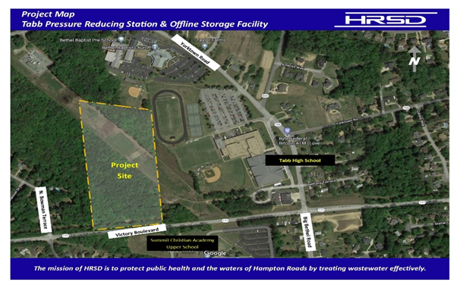
Design Completion: Summer 2022

Construction: Fall 2022 - Spring 2024

If you are unable to attend this open house and would like to obtain more information, please contact:

PIS Name, HRSD Public Information Specialist
Phone: PIS phone number
Email: PIS email address

